Introduction
Welcome to your favorite AICT Lab. In this lab manual, we shall work together to learn and implement new computing concepts.

Skills to be learned:

- MS WORD

Week 3 | Use MS-WORD:  - To Create a Poster  - Explorer Review tab in MS word  - Track changes into your MS word Report  - To make kindergarten games  - To Create Lab Manual for ICS | CLO1

.

Let's do some computing

Good Luck and Best Wishes !!
Happy Computing ahead :)

MS Office

MS WORD
Professional
Documentations

CS-141L Introduction to computing
Create a poster for a sports gala for CS department UET. Lahore
Objectives
To get familiar with different effective components that is important in creating a poster. Learn how to insert pictures and use different schemes.
Processing steps
- Open a new blank Word document.
Setting page size
- Set the paper width and height to 22” by 22’’. For this click on the layout tab and select size. From the drop-down list select more paper sizes.
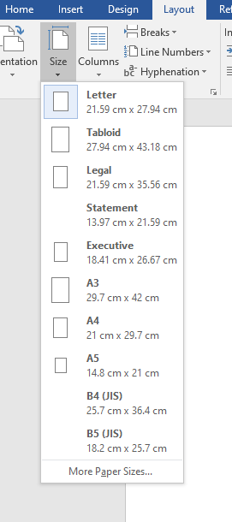
Figure 13-paper size

Page Setup dialog box appears. Change the width and height to 22’’ and click OK.
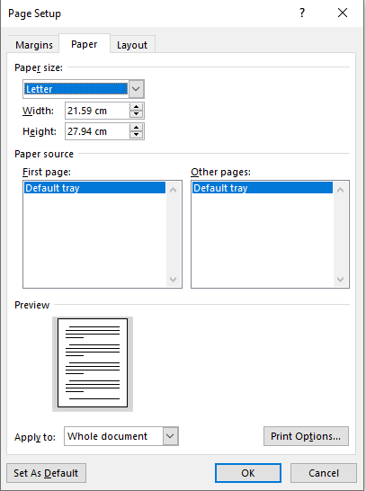

Figure 14-page setup dialog box
Inserting pictures
First of all, insert the picture related to the given topic. Click Insert tab and select pictures options.
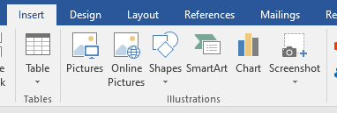

Figure 15-insert pictures
Insert pictures dialog box appears. Select the desired picture you want to insert and then click insert.
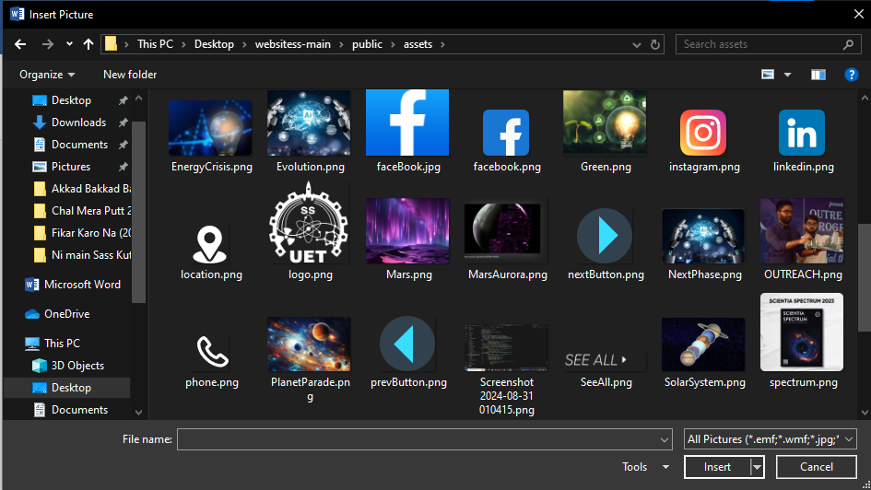

Figure 16-insert picture dialog box
Formatting picture
To format the picture, select the picture and then select Format Picture from the drop-down list.
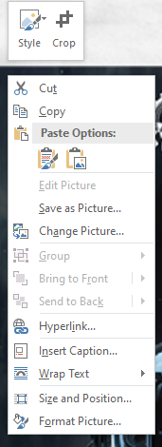
Figure 17-selecting picture for formatting

Format picture pane appears which helps to crop the picture, changing picture colours, applying 3-D rotation and many more.
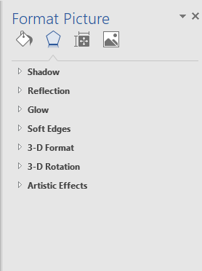
Figure 18-formatting picture
Inserting and formatting text in pictures
Text can be inserted by selecting the picture and then selecting the wrap text option from the drop-down list or from the layout options.
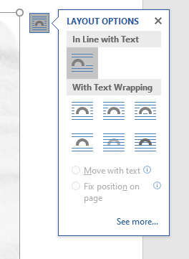

Figure 19-wrap text option
Text colours can be changed from the theme colours available in Font group from Home tab.
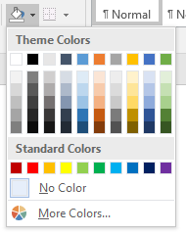
Figure 20-font colour palette
Text highlight colour and text effects can also be applied from the font group.
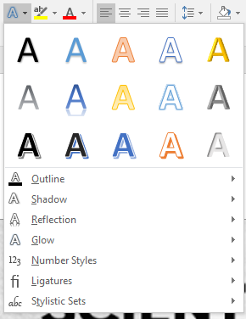
Figure 21-text effects

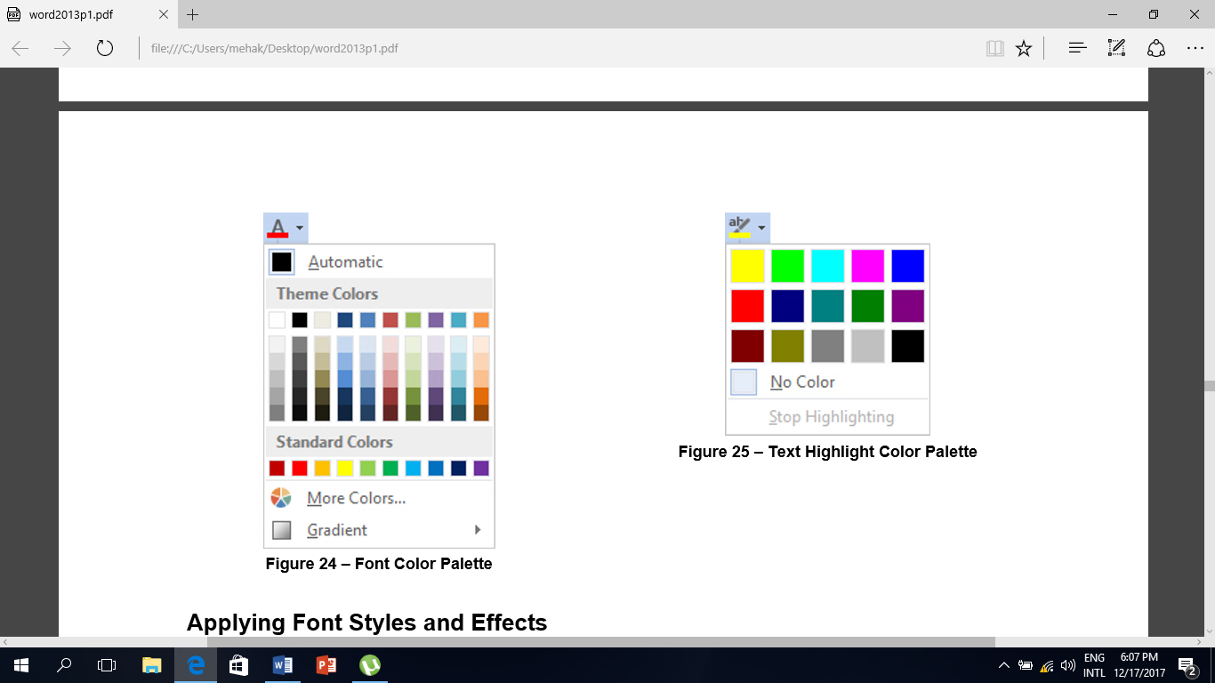
Figure 22-text highlight colour palette
On Insert tab, click on arrow 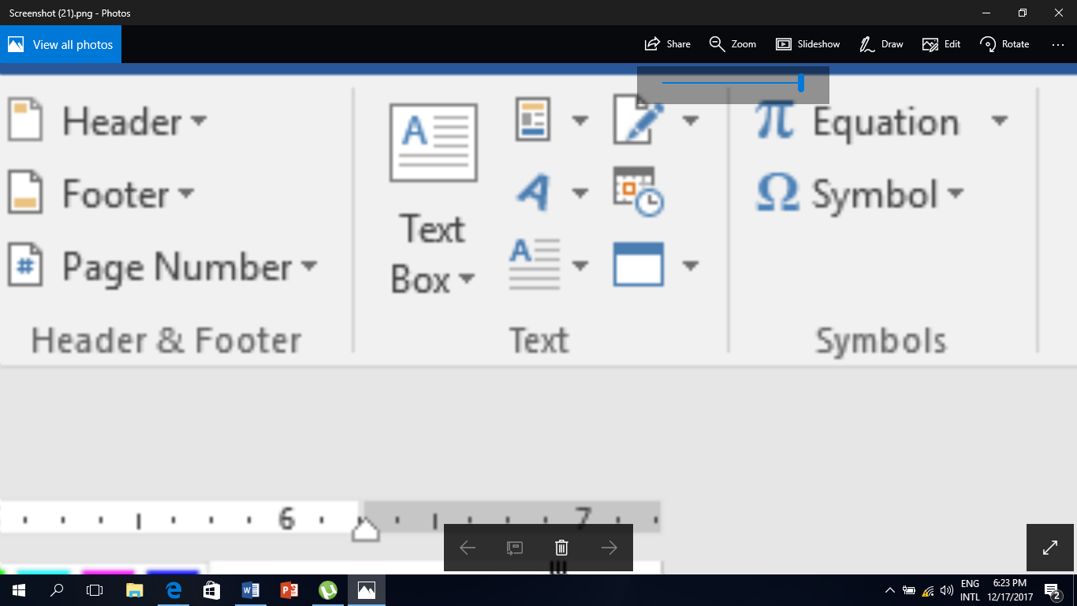 and select desired Word Art.
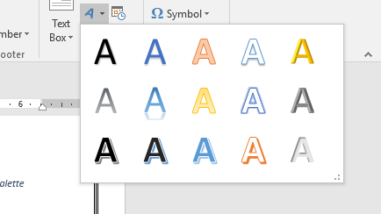
Figure 23-word art
Colour of background can also be changed. Go to Design tab and select Page Color and change the colour to the desired one.
Print preview of document
Check the print preview of the poster. To do this, select the File tab and then select Print option.
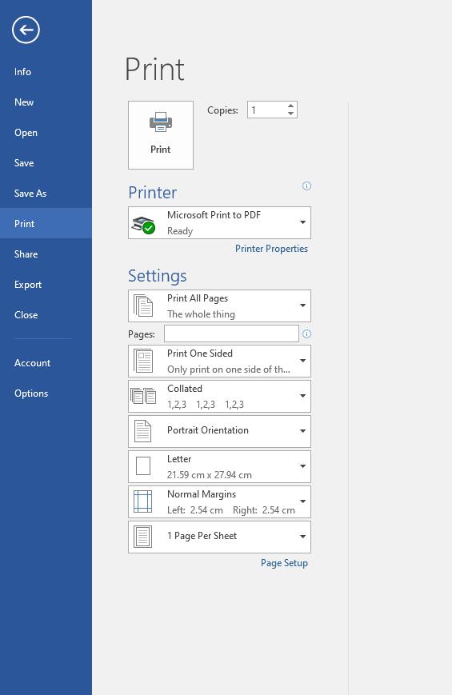
Figure 24-checking print preview
After checking the print preview, save the poster with desired name.
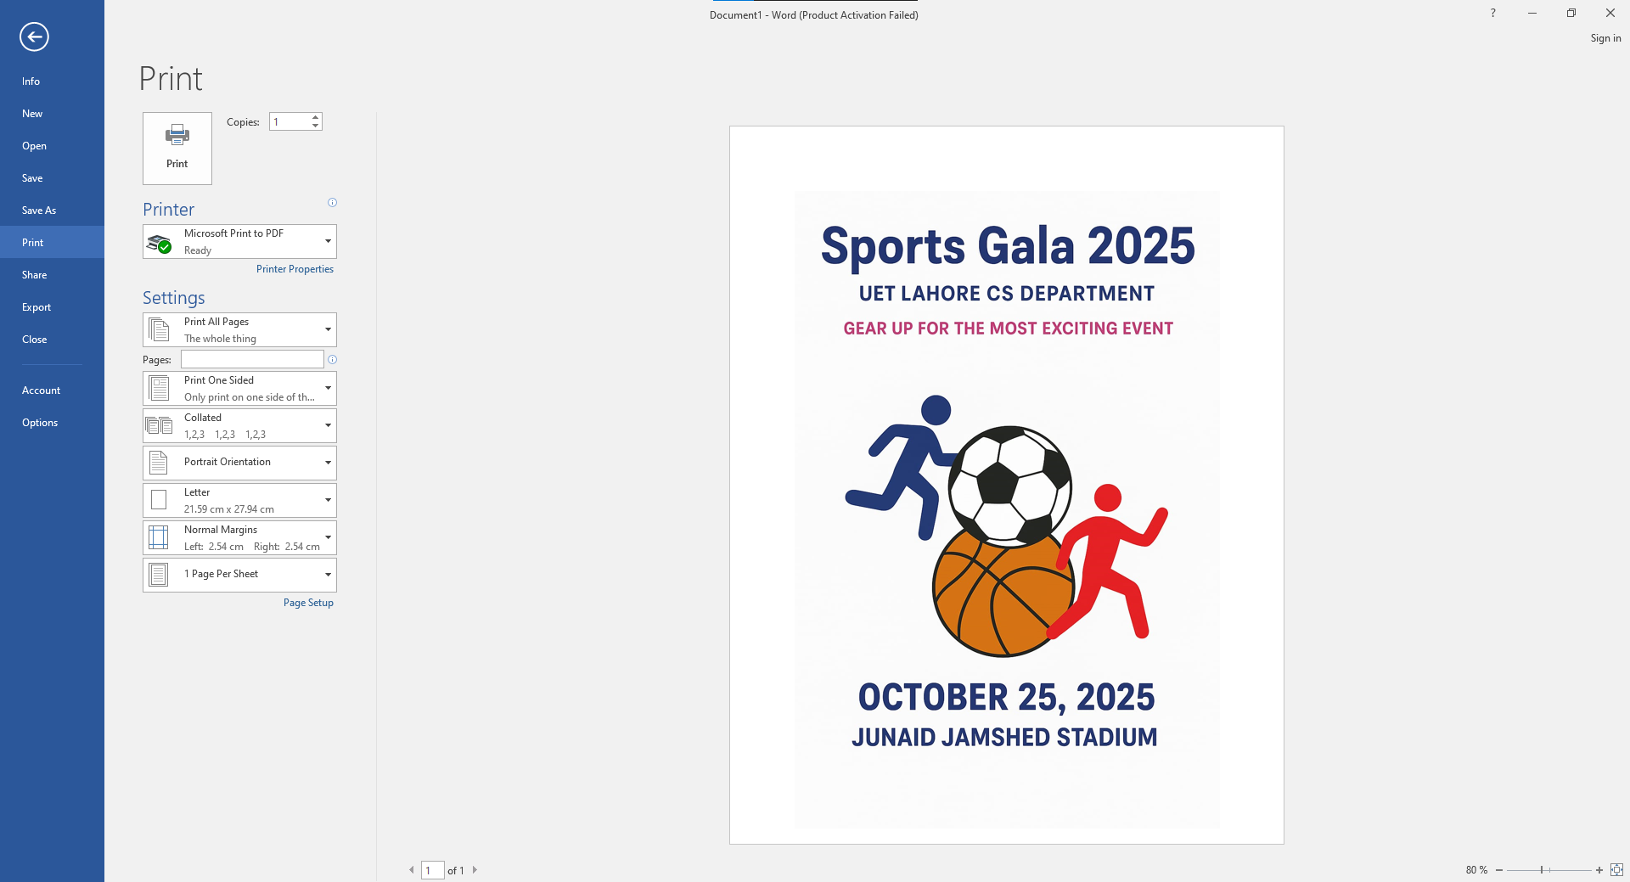
Figure 25-print preview of document
Conclusion
After following the above steps, one can learn how to set paper size, insert pictures, and format a picture. How to insert text in a picture and format it, how to check the print preview of a document.

Sample:

Figure 26: Sample document

CS-141L Introduction to computing
Create activities for kindergarten students.
Objectives
To learn how to create simple yet effective activities using MS Word features like inserting tables, pictures and adding borders.
Processing steps
First of all, give the heading at the top of the page. Double click at the top of the page to activate header and footer bar and add header.
Applying page borders
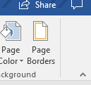
- Add a border to the page. Click on the design tab and select page border on the page background group. Borders and shading dialog box will appear.
- Select the desired border and click OK.
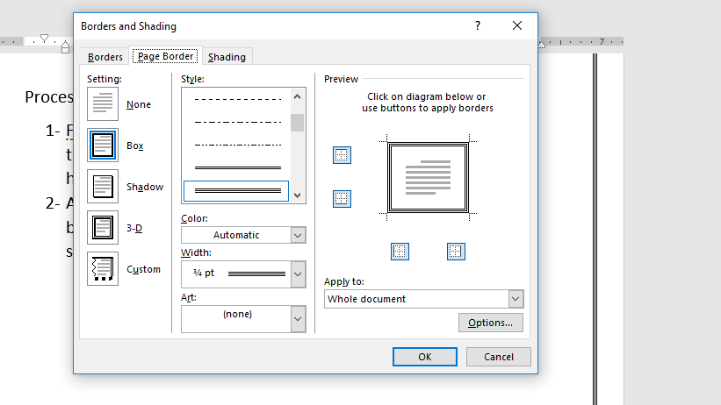

Figure 39-page borders
Inserting table
Insert table in the page. Select the insert tab and click on table button in the tables group and select desired number of rows and columns.
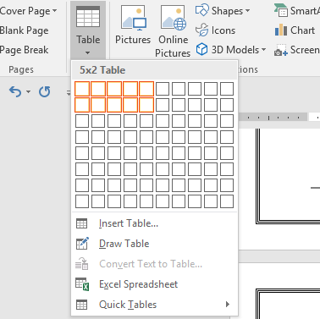

Figure 40-inserting table
Insert pictures in the table and text according to the requirement. And save the activity.
Conclusion
After following the above steps one can learn how to add page Borders and insert table in the document and format it.
Sample: 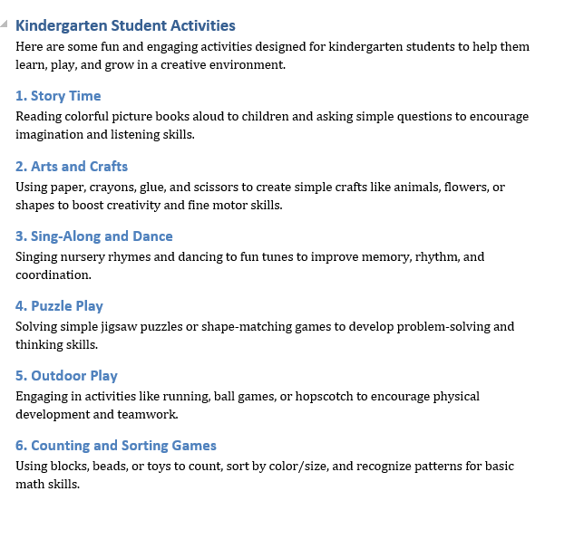
Figure 41: Sample document

CS-141L Introduction to computing
Create references in IEEE format.
Objectives
To learn how to use standard format to create references using simple features of MS Word.
Processing steps
On the References tab, in the Citations & Bibliography group, click the arrow next to Style.
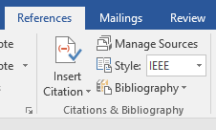
Figure 42 inserting reference
Create references using references tab
- First of all, go to the References tab and click on manage sources button. Source manager dialog box will appear.
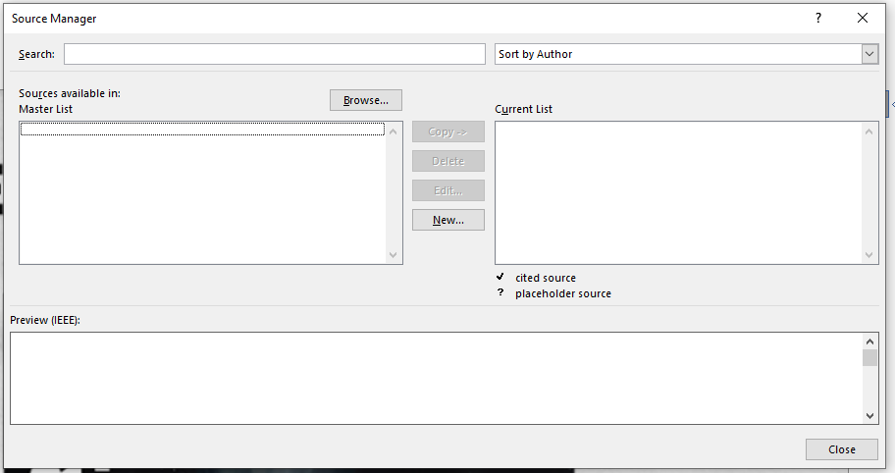
Figure 43-source manager dialog box
- Click on New and the following box will appear.
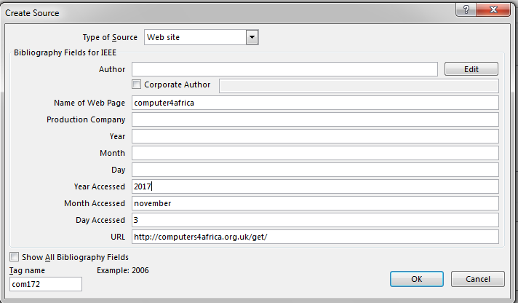
Figure 44-create source dialog box
- Select the type of source. Enter all the specifications and click OK.
- Similarly, to create more references again click on new option and select the source type and fill all the specifications.
- After completing all the references, click on close option.
- After doing that, click on the arrow next to BIBLIOGRAPHY and select REFERENCES from the dropdown menu.
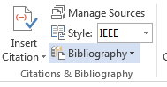

Figure 45-bibliography
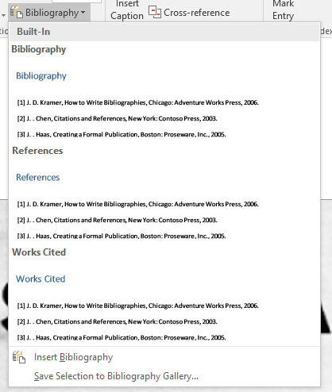
Figure 46 Reference and bibliography
Conclusion
After following these steps one can learn to add text and references in IEEE format.

Sample
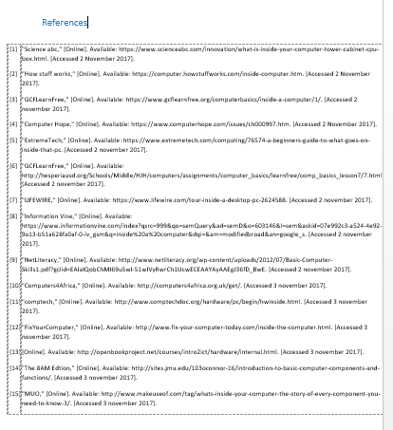
Figure 47: Sample documentation

